Exercise 3: **Stored Procedures**

**A stored procedure is a named PL/SQL block that performs a specific task and is stored permanently in the database.  
Unlike anonymous blocks, it can be invoked by name any number of times.**

**▪ Scenario 1 (Solution):**

The bank needs to process monthly interest for all savings accounts.

◉ Question: Write a stored procedure **ProcessMonthlyInterest** that calculates and updates the balance of all savings accounts by applying an interest rate of 1% to the current balance.

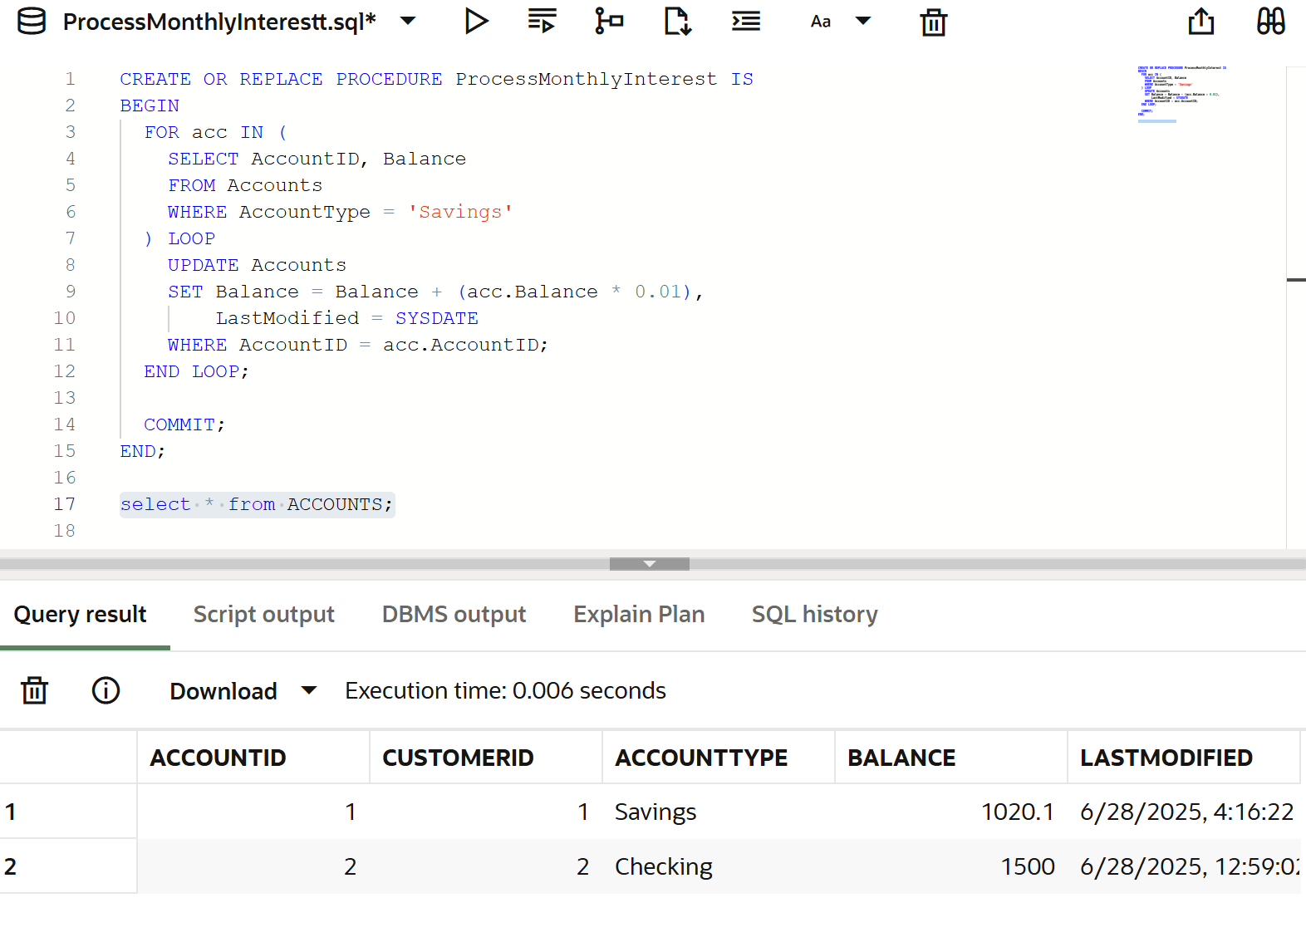

**▪ Scenario 2 (Solution):**

The bank wants to implement a bonus scheme for employees based on their performance.

◉ Question: Write a stored procedure **UpdateEmployeeBonus** that updates the salary of employees in a given department by adding a bonus percentage passed as a parameter.

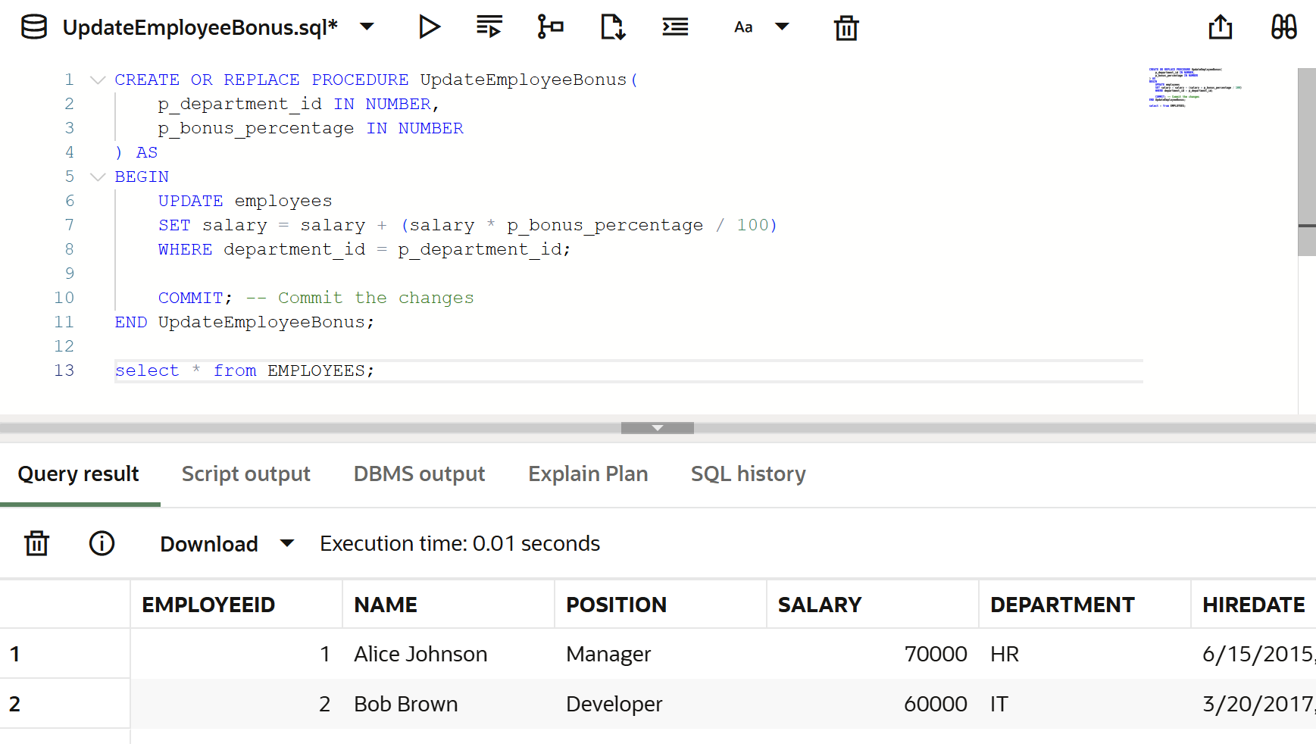

**▪ Scenario 3 (Solution):**

Customers should be able to transfer funds between their accounts.

◉ Question: Write a stored procedure **TransferFunds** that transfers a specified amount from one account to another, checking that the source account has sufficient balance before making the transfer.

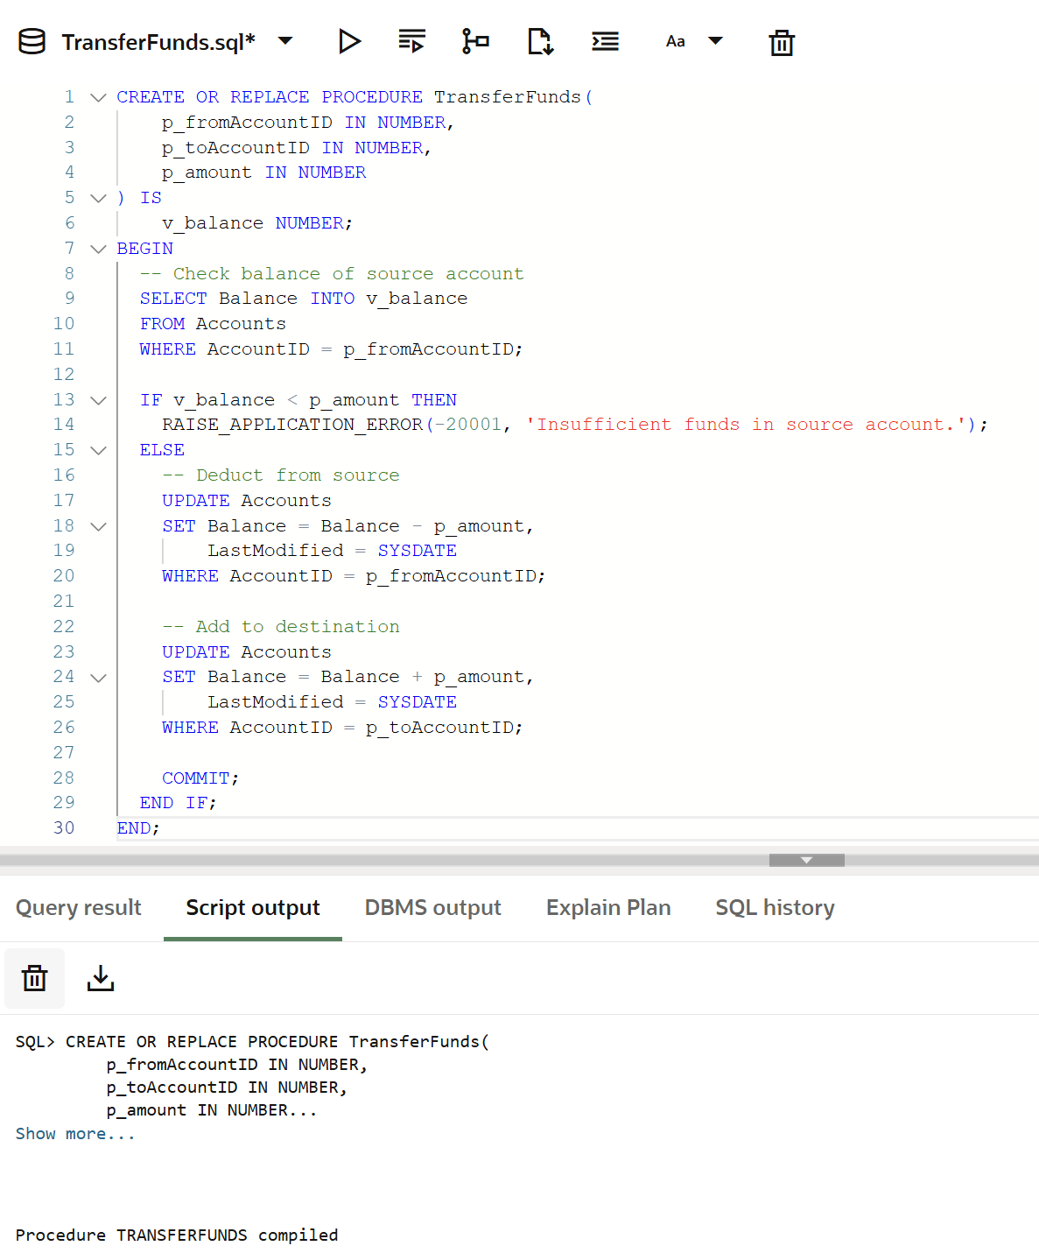

Source: Live SQL Oracle-website.

********************* ********************************************* *********************